Bureau of Primary Health Care (BPHC)
Scope Verification:
User Guide for Grantees

Table of Contents
1. Introduction 4
2. Significance of the Scope Verification Requirement 4
3. Completing the Scope Verification Submission in EHB 5
3.1. Accessing the Scope Verification Submission through the Other Submissions Page 5
3.2. Accessing a Service-Related Scope Verification Submission through the Approved Scope/Self-Update Module 7
3.3. Accessing a Site-Related Scope Verification Submission through the Approved Scope/Self-Update Module 9
3.4. Completing the Scope Verification Submission (For a single site or service) 10
3.4.1 Pending Verification 11
3.4.2 Implemented 11
3.4.3 Will Not Implement 11
3.4.4 Requesting Extension 11
3.5. Completing the Scope Verification Submission (For Bundled services) 12
3.5.1 Form 5A Sections 13
3.5.2 Additional Information 14
3.5.3 Review and Submit 15
4. Project Officer Requests Change 16
5. Copying a Change in Scope (CIS) Request 17
6. Help and Support 17

Table of Figures
Figure 1: Grant Home Page 7
Figure 2: Submissions Page 7
Figure 3: Services and Sites under Approved Scope on the Left Side Menu 8
Figure 4: Self Updates: Services Details 8
Figure 5: Self Updates: Required Service Pending Approved Changes 9
Figure 6: Sites in Scope in Approved Scope/Self-Update Module, Showing 1 Site with a Scope Verification Submission 10
Figure 7: Self Updates: Pending Approved Changes 10
Figure 8: Sample Single Scope Verification Submission 11
Figure 9: Status Overview Page 13
Figure 10: Sample of a Form 5A Section 14
Figure 11: Additional Information Section 15
Figure 12: Review Page 16
Figure 13: Submit Page 17
Figure 14: Copy Request functionality 18

Introduction
Policy Information Notice (PIN) 2008-01 establishes expectations for the implementation of changes to your scope of project when those changes involve adding or deleting a service or adding, deleting or replacing a service site.
The PIN identifies five changes to your scope that are deemed significant enough to require prior approval from HRSA:
- Adding a service
- Adding a new service site or converting an existing admin site to a service site
- Replacing a service site
- Deleting a service
- Deleting a service site or converting an existing service site to an admin site
For such changes, you are given 120 calendar days from the date HRSA releases the Notice of Award (NoA) to implement the change. In addition, when you have implemented the change, you must verify this through the HRSA Electronic Handbook (EHB).
The purpose of this user guide is to give detailed instructions for fulfilling the Scope Verification requirement in the EHB.
Note: This user guide is not intended to provide policy guidance. Nor does it replace applicable Policy Information Notices (PINs) or Program Assistance Letters (PALs). These can be reviewed or downloaded at the BPHC website.

Significance of the Scope Verification Requirement
As noted above, PIN 2008-01 stipulates that you secure prior approval from HRSA for any proposed change to your scope of project that involves adding a service, deleting a service, adding or replacing a service delivery site or deleting a service delivery site. HRSA will indicate its decision on a Change in Scope request within 60 days of receiving a complete request either by issuing a Notice of Award indicating approval or by sending an e-mail through the HRSA Electronic Handbook indicating disapproval.
You are given 120 calendar days from the date HRSA releases the NoA to implement the change to your scope. When HRSA approves the change and releases the NoA, a Scope Verification Submission is created in your EHB pending tasks. The proposed change is reflected in your scope when the NoA is released, but the change is flagged as “pending verification” and cannot be selected for any purpose (such as another CIS or program specific application) until it is verified or the respective Scope Verification Submission expires.
You must verify that you have implemented the change by submitting this Scope Verification Submission in EHB. In the Scope Verification Submission, you may either verify that you have implemented the change or you may indicate that you will not implement the change. You will not have the option to propose any new or additional changes. In the case where you will not implement the change, no change is made to your scope.
If you cannot submit the Scope Verification Submission within the 120-day period, because the change has not yet been implemented, you may, request an extension of up to 90 days from within the Scope Verification Submission in EHB. Extension requests are subject to review and approval by HRSA. The time HRSA spends reviewing your request will not count against any additional time you may be granted.
If you do not complete the Scope Verification Submission within 210 (120 plus an approved additional 90) days of the issuance of the NoA, the submission expires and no change is made to your scope. If you still want to make the change, you will have to submit a new Change in Scope request. If appropriate, you can copy a previously-submitted Change in Scope request and submit it with necessary revisions.
The Scope Verification module allows HRSA to track changes to your scope more precisely. New services and service delivery sites become active when you verify their addition; site replacements are effective when you verify them, and services and sites that are no longer active are removed as soon as HRSA approves.
Note: The verification clock only ticks while the Scope Verification Submission is pending with the grantee. If you request an extension, the clock stops while HRSA reviews your request. It starts again when HRSA again makes the Scope Verification Submission available to you. For this reason, it is possible (though not altogether likely) that the Scope Verification process could take longer than the maximum of 210 calendar days to complete.

Completing the Scope Verification Submission in EHB
To complete the Scope Verification submission, login to EHB and access the Scope Verification Submission in your pending tasks.
Note: if you do not have a username, then you must register in EHB. Do not create duplicate accounts. If you experience login issues or forget your password, contact the BPHC Helpline for assistance at http://www.hrsa.gov/about/contact/bphc.aspx or 1-877-974-2742 (Monday – Friday, 8:30 AM - 5:30 PM ET).
There are two ways to access the Scope Verification Submission – through the Submissions page and the Approved Scope section.

Accessing the Scope Verification Submission through the Other Submissions Page
- Navigate to the EHB login and enter your login credentials.
- Click the Grants tab to navigate to the My Grant Portfolio – List page.
- Click the Grant Folder link respective to the desired grant to navigate to the Grant Home page.
- On the Grant Home page, click the Work on Other Submissions link (refer to Figure 1) to navigate to the Submissions page
Figure 1: Grant Home Page
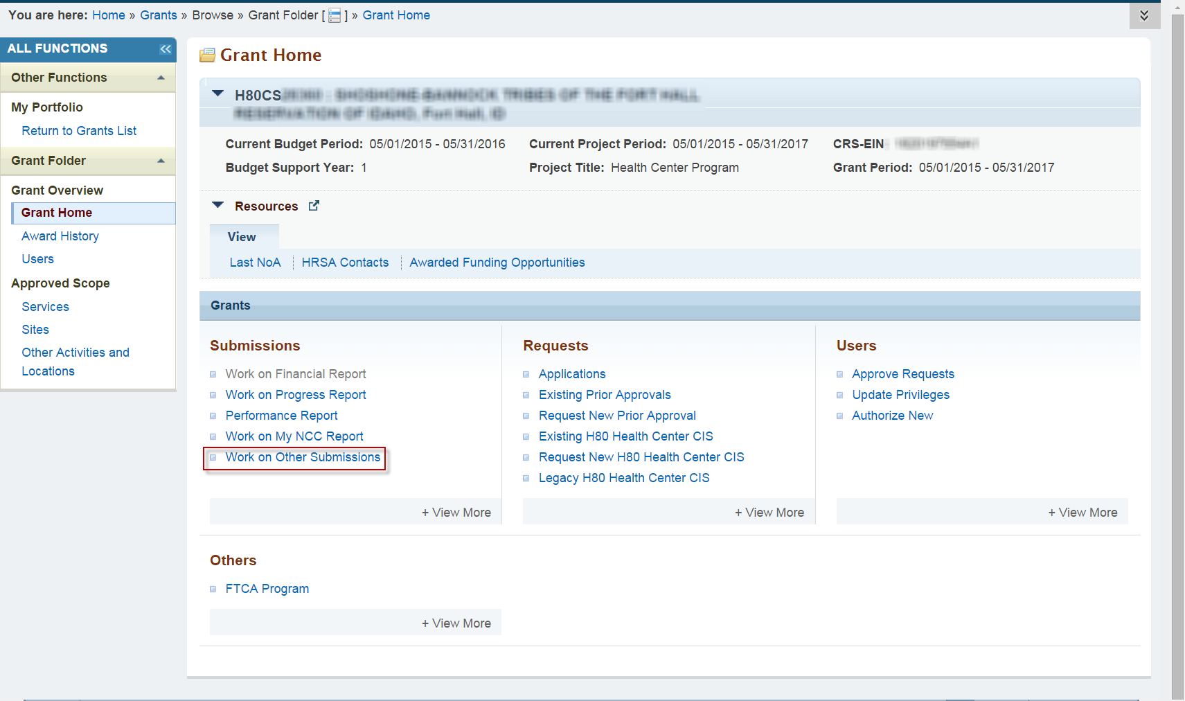

- The Submissions page (refer to Figure 2) lists all of the assigned Scope Verification Submissions, if any. Select the Not Completed tab in order to only see submissions that have not been completed yet.
- Access the search fields by clicking Search. Filter the list page by inputting the Scope Verification tracking number (of a bundled Scope Verification) into the search page field Submission Tracking Number Like. Click Search.
- Click the Start/Edit button of the searched Scope Verification Submission row to access the submission.
Figure 2: Submissions – Incomplete List
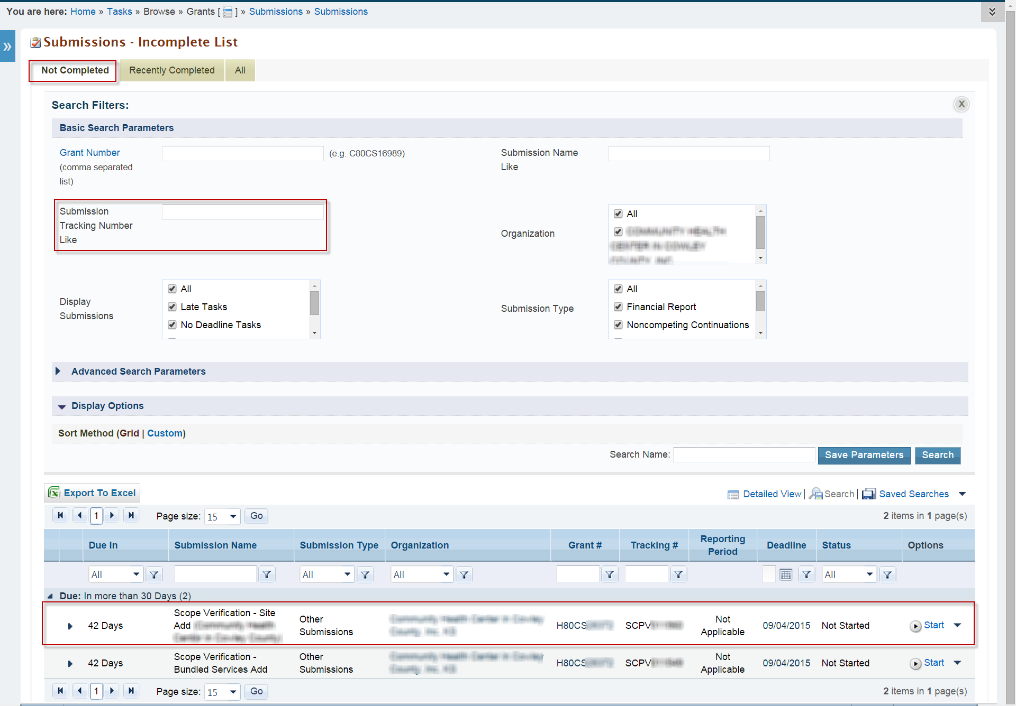
To complete the Scope Verification Submission, proceed to 3.4 or 3.5 below.

Accessing a Service-Related Scope Verification Submission through the Approved Scope/Self-Update Module
- On the Grants Home page, locate Approved Scope on the left side menu (refer to Figure 3). Under Approved Scope, click Services. This navigates to the Self Updates: Services Details page (refer to Figure 4).
Figure 3: Approved Scope in Grants Home Left Menu
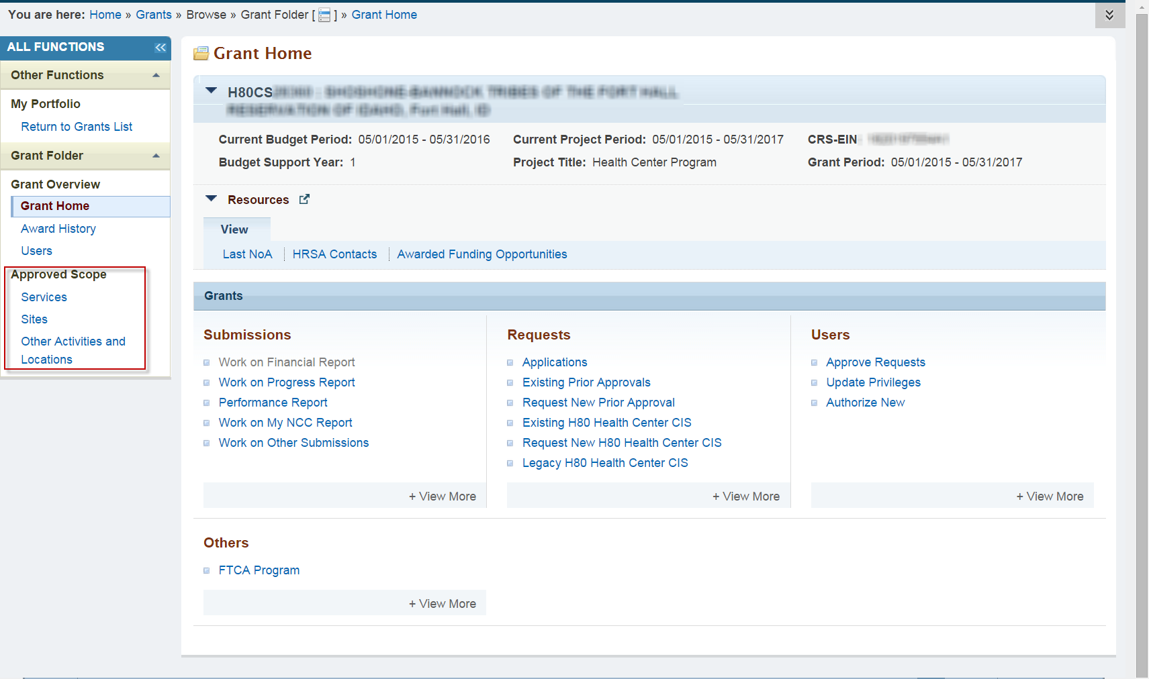
- Click Pending Approved Changes (#) (the (#) indicates the number of services to be verified) under the Required Services column to navigate to the Self Updates: Required Services Pending Approved Changes page. This page lists the services to be verified.
Figure 4: Self Updates: Services Details
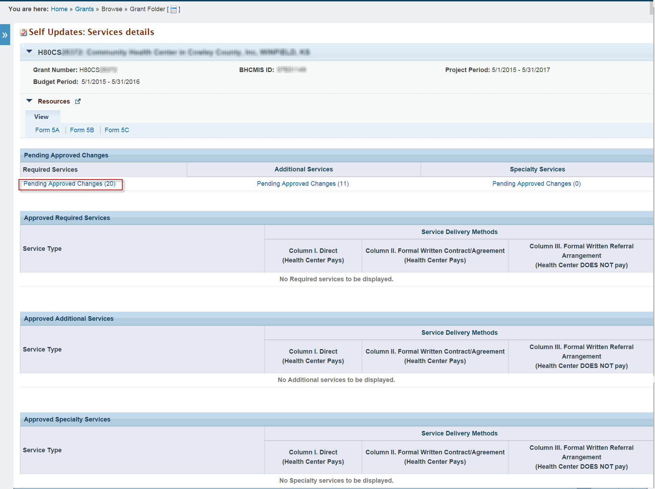
- Click Verify for one of the listed services to open the respective Scope Verification Submission (refer to Figure 5).
Figure 5: Self Updates: Required Service Pending Approved Changes
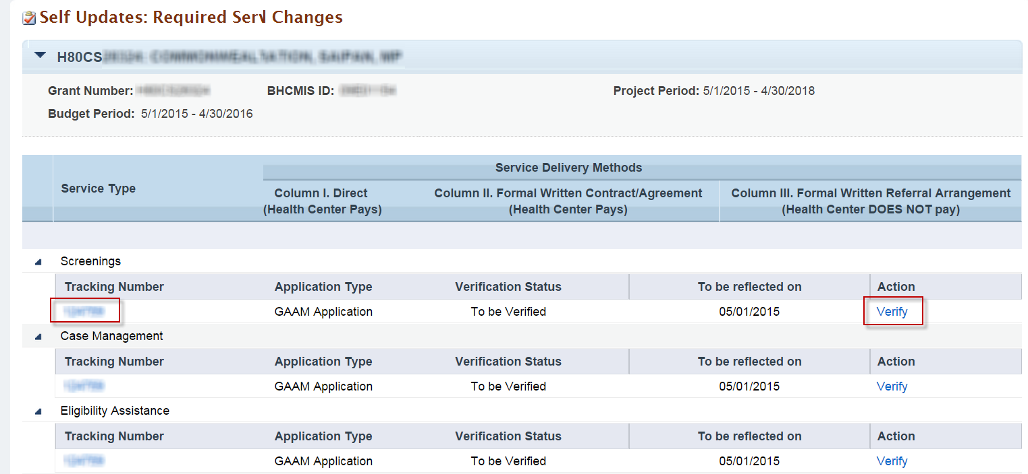
To complete the Scope Verification Submission, proceed to 3.4 or 3.5 below.

Accessing a Site-Related Scope Verification Submission through the Approved Scope/Self-Update Module
- Click Sites in the left menu to navigate to the Self Updates: Sites in Scope page (refer to Figure 6).
Figure 6: Sites in Scope in Approved Scope/Self-Update Module, Showing 1 Site with a Scope Verification Submission
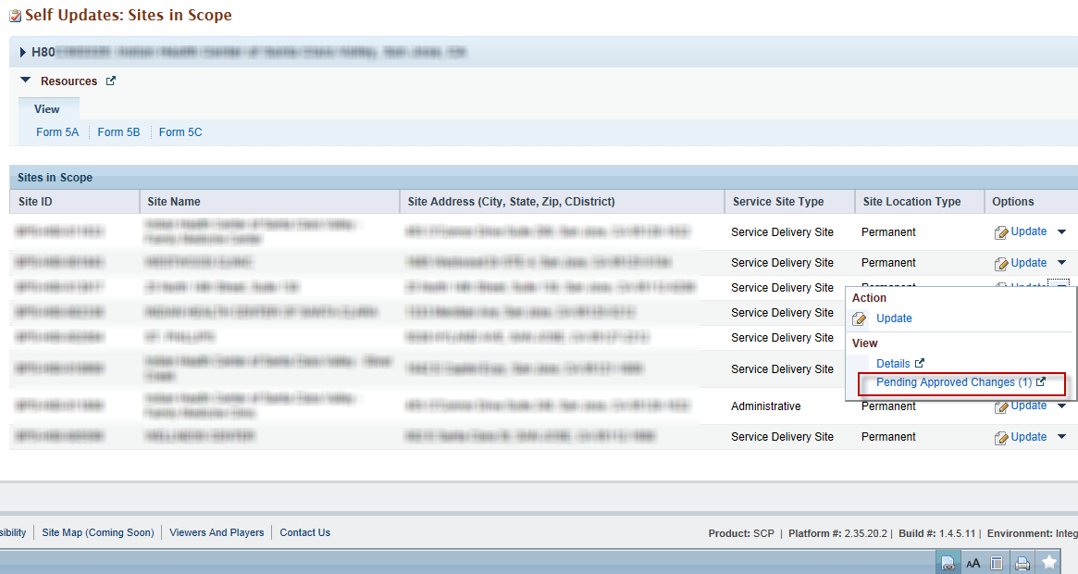
- Under the Options context menu, click the Pending Approved Changes link for a site with Pending Approved Changes to view the Self Updates: Pending Approved Changes page (refer to Figure 7).
- If desired, click the Tracking Number to open, in a popup window, an HTML-format copy of the CIS request or GAAM application from which the service was created.
- Click Verify under the Options column to open the Scope Verification Submission.
Figure 7: Self Updates: Pending Approved Changes

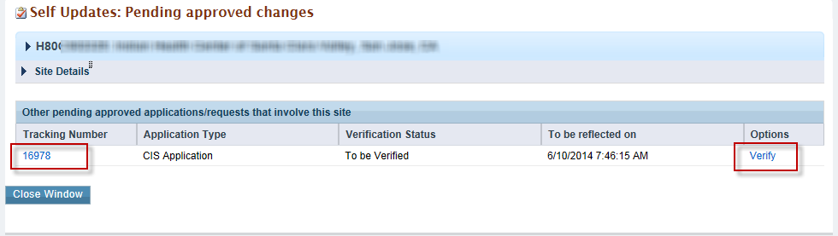
To complete the Scope Verification Submission, proceed to 3.4 or 3.5 below.

Completing the Scope Verification Submission (For a single site or service)
Clicking Start (or Edit) opens the Scope Verification page, showing the Scope Verification Submission (refer to Figure 8).
Figure 8: Sample Single Scope Verification Submission
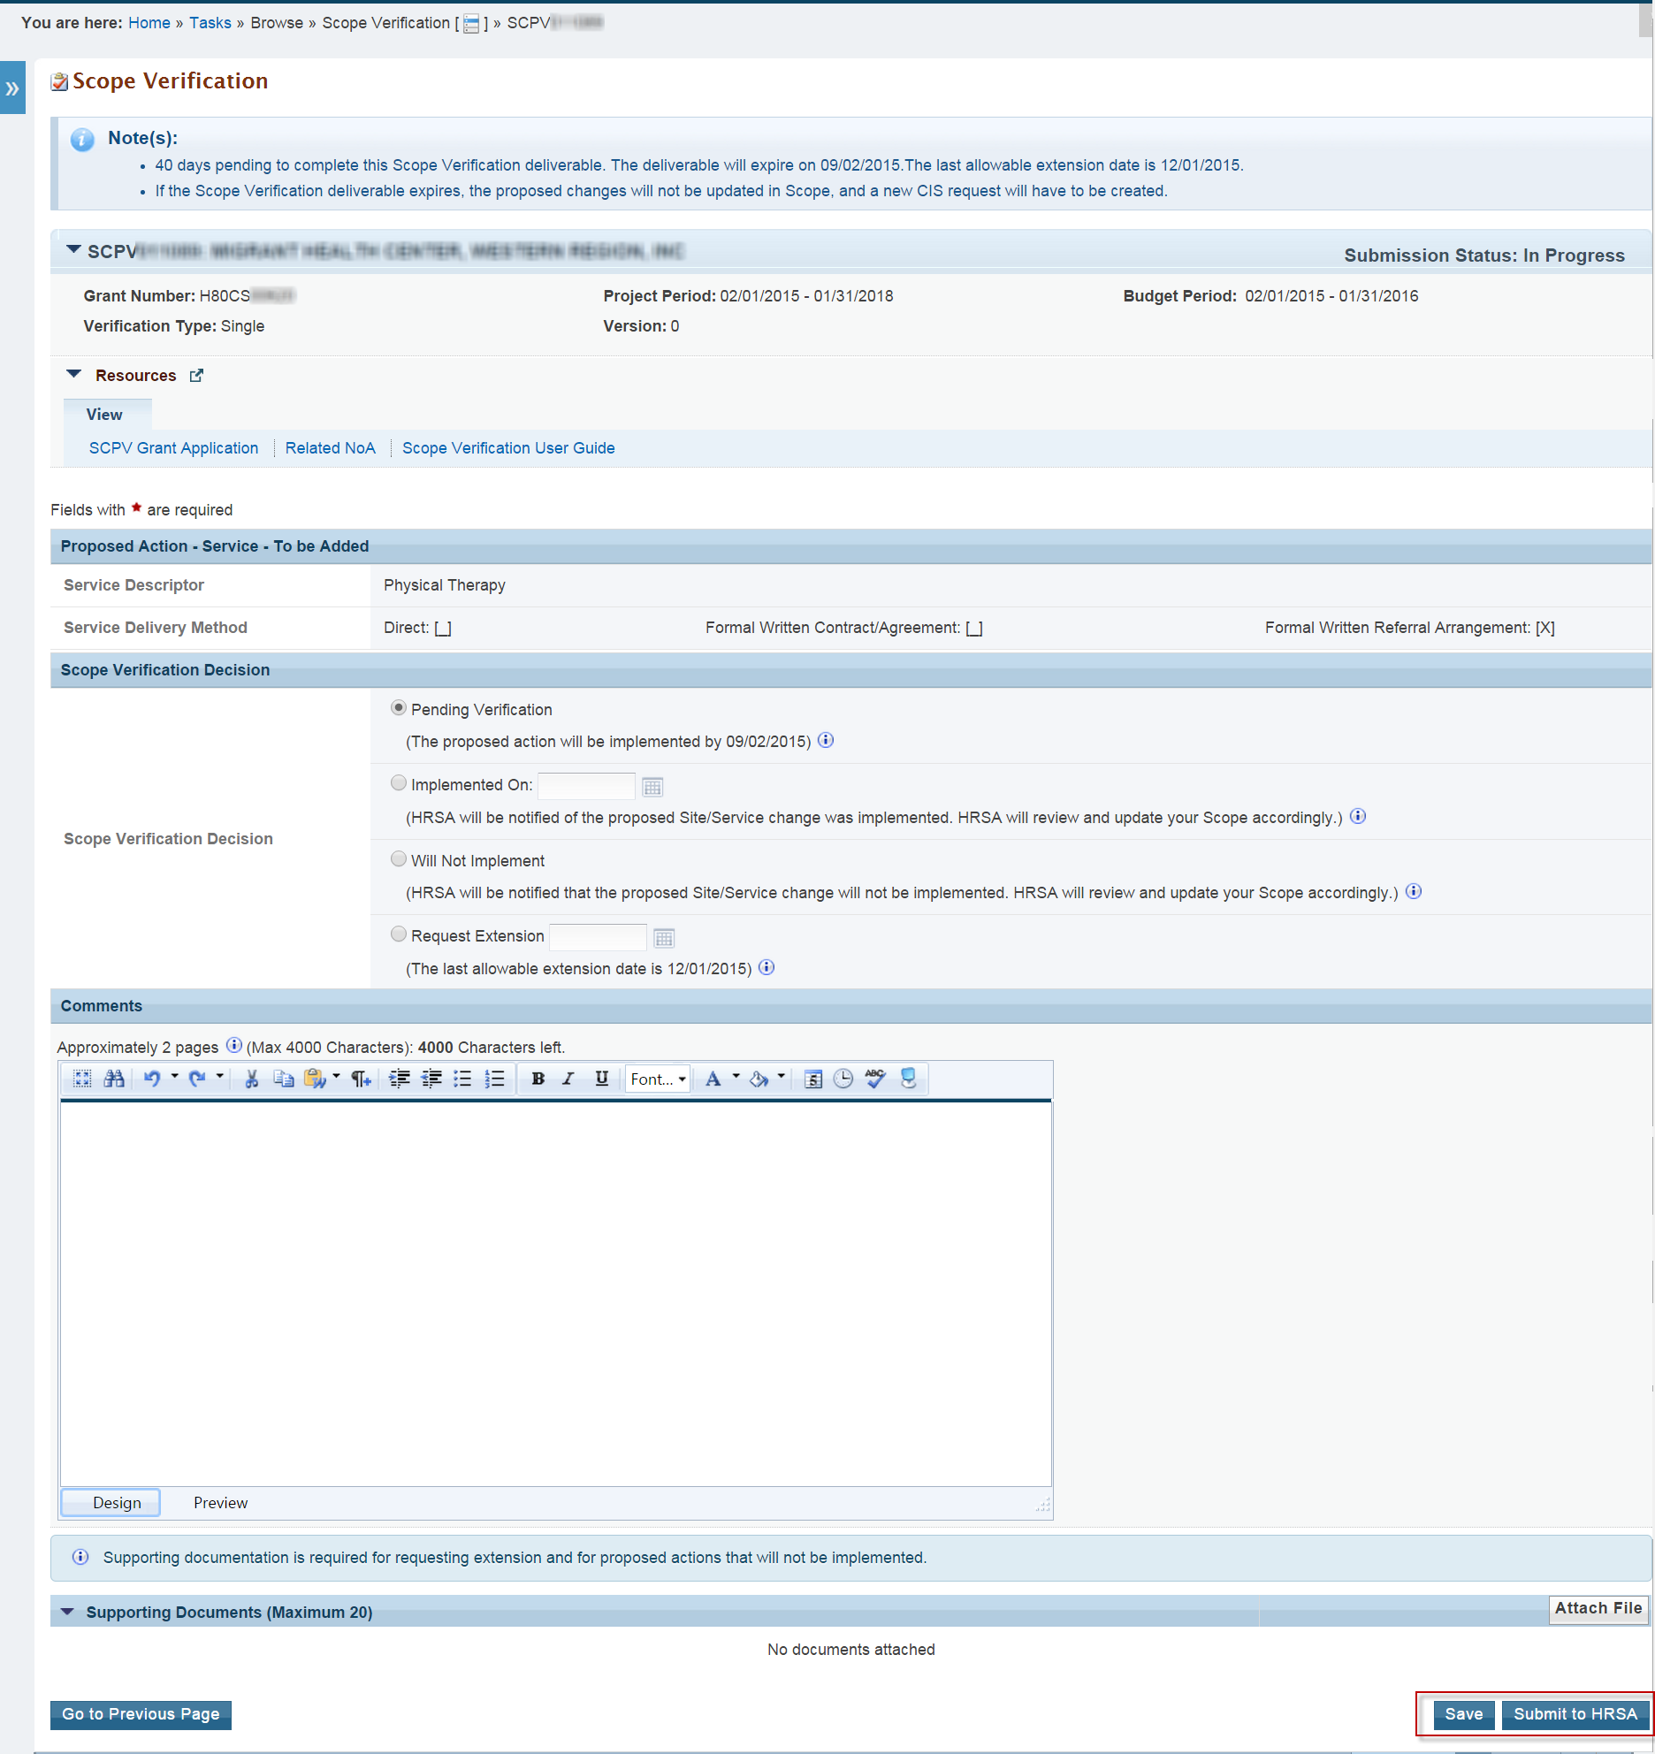
Follow the on-screen instructions and tooltip language respective to each decision to complete the Scope Verification Submission. You must select one Scope Verification Decision.
Note: You may request additional time if you are unable to complete the Scope Verification Submission within the allotted time. See section 3.4.4 below.
You have the option to provide any comments or supporting documentation in the Comments and Supporting Documents sections. Supporting documentation is required in order to not implement or request extension.
Click the Save button to save any work.
Click the Submit to HRSA button when the Scope Verification is ready for submission. The system will populate a read-only version of the submission with a success message.
Refer to the following Sections 3.4.1 – 3.4.4 for the available decisions you have when working on a Scope Verification Submission.

Pending Verification
Select this option if the proposed action has not been implemented, but will be implemented by the expiration date.

Implemented
Select this option if the proposed action has already been implemented. Provide an implementation date later than or equal to the BPHC Approval Date (if Scope Verification came from a CIS request) or NoA Release Date (if Scope Verification came from a grant application) and prior to or equal to the current date.

Will Not Implement
Select this option if the proposed action will not be implemented.

Requesting Extension
Select this option to request up to 90 additional days if you cannot verify the change to your scope within the 120-day verification period. To request additional time, select the decision Request Extension and provide a date later than the current deadline and prior to or equal to the last allowable extension date.

Completing the Scope Verification Submission (For Bundled services)
Click Start (or Edit) to open the Status Overview page (refer to Figure 9). The left menu provides links that allow you to navigate to any of the pages within the Scope Verification Submission. You can also navigate to any Form 5A page or the Additional Information page by clicking the respective Update button in the Scope Verification Status section.
Figure 9: Status Overview Page
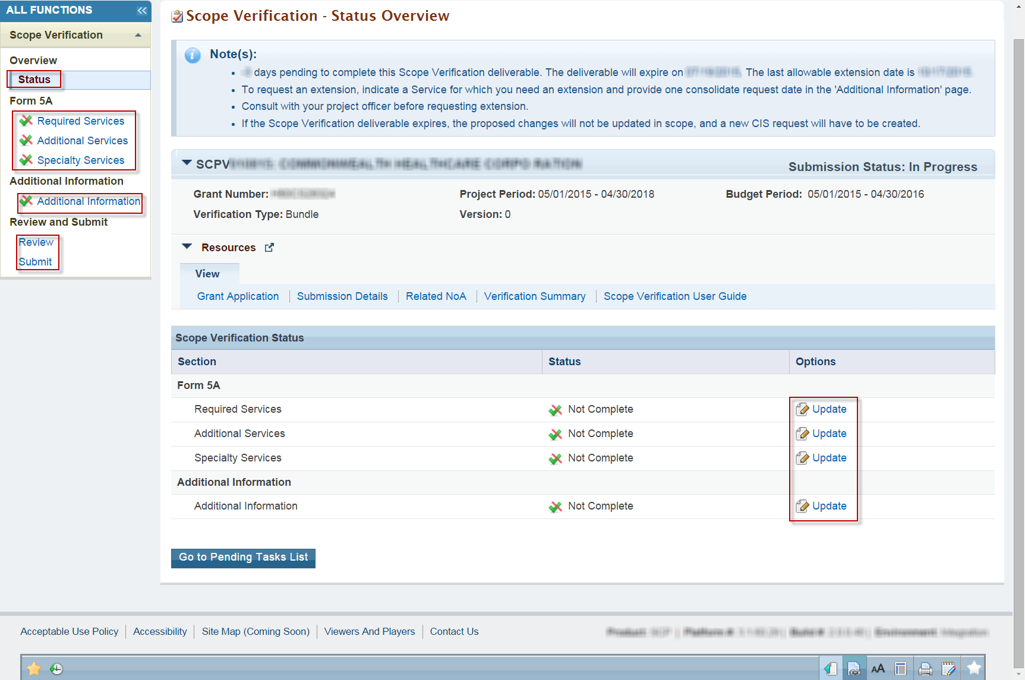

Form 5A Sections
Each of the Form 5A sections (Required Services, Additional Services, Specialty Services) must be completed in order to submit the Scope Verification Submission (refer to Figure 10). Refer to the tooltip language for guidance on which decision to select.
The Scope Verification Submission cannot be submitted with every service marked as Pending Verification.
You can choose to request extension for each service as necessary. Provide only one extension request date for all services you requested an extension for, on the Additional Information page (refer to Figure 10).
Navigate to the previous page by clicking the Go to Previous Page button. Click the Save button to save your work on the page. Click the Save and Continue button to save your work on the page and navigate to the next page.
Figure 10: Sample of a Form 5A Section
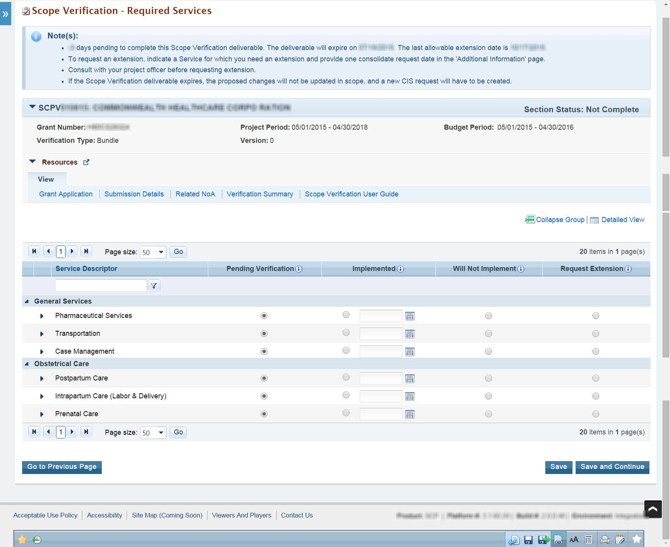

Additional Information
The Additional Information page (refer to Figure 11) is where the extension request date, comments, and supporting documentation can be provided.
Navigate to the Specialty Services page by clicking the Go to Previous Page button. Click the Save button to save your work on the page. Click the Save and Continue button to save your work on the page and navigate to the Review page.
Figure 11: Additional Information Section
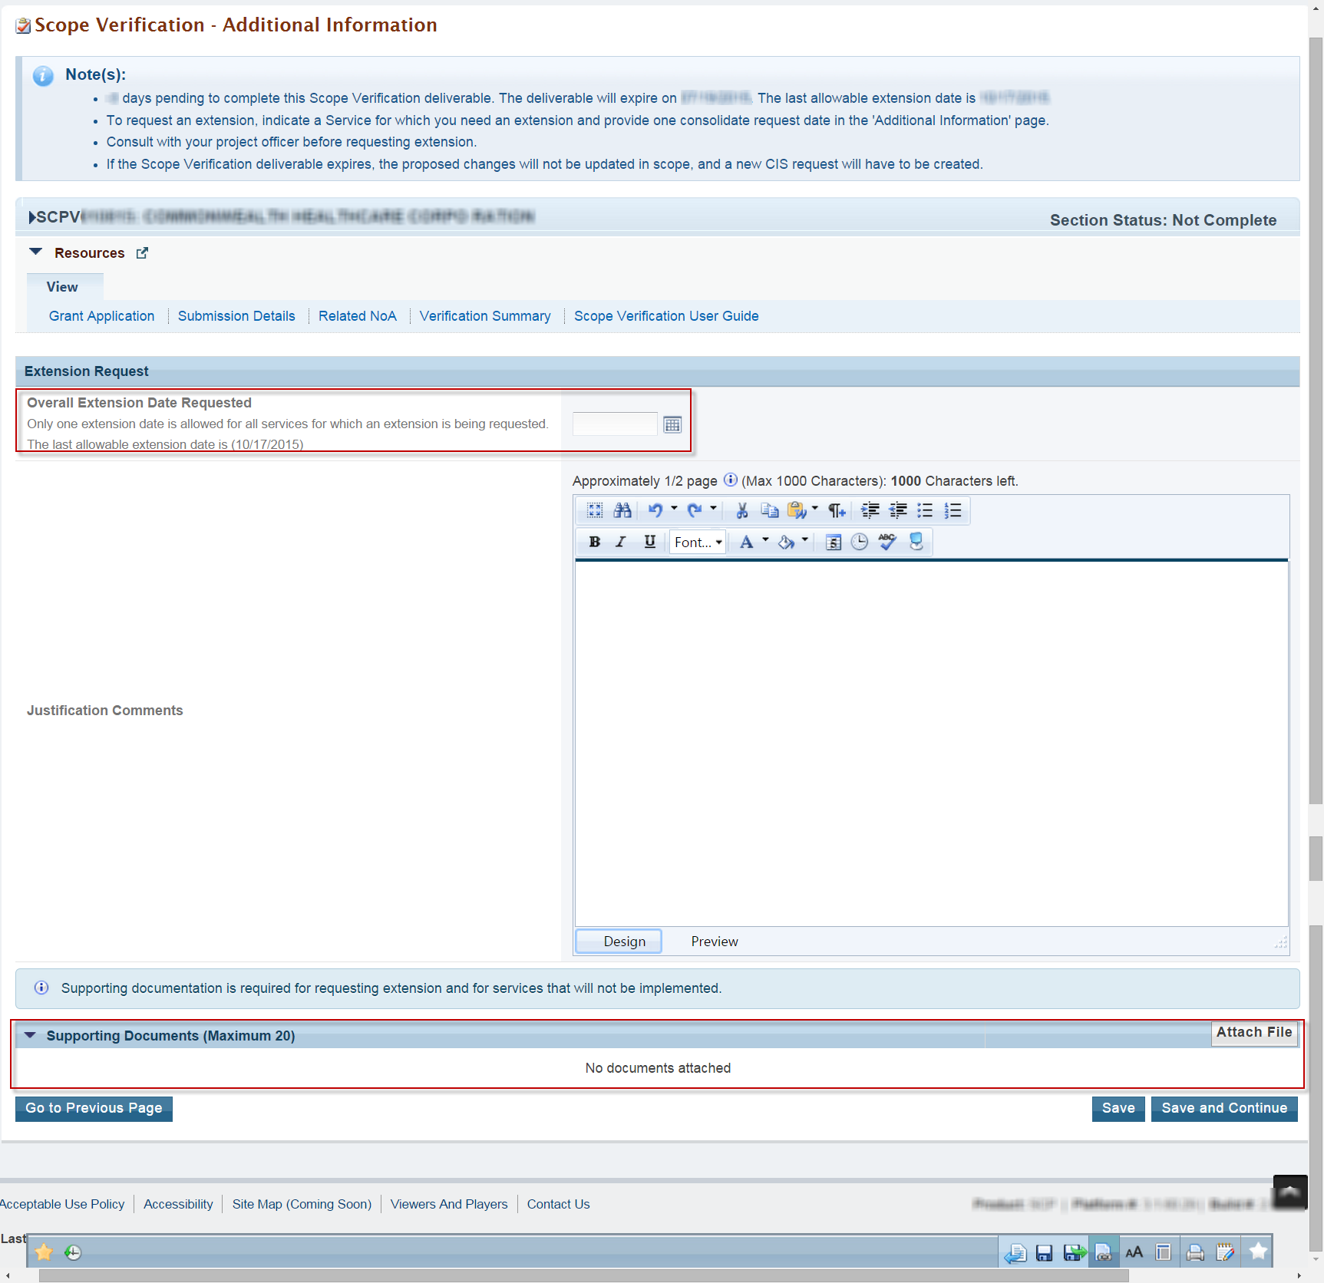

Review and Submit
The Review page (refer to Figure 12) allows access to a read-only view of each of the Form 5A sections, the Additional Information section, and any supporting documentation provided. Access a read-only view of a section or supporting documentation by clicking the section’s respective View button. Navigate to the Submit page by clicking the Proceed to Submit button.
Figure 12: Review Page
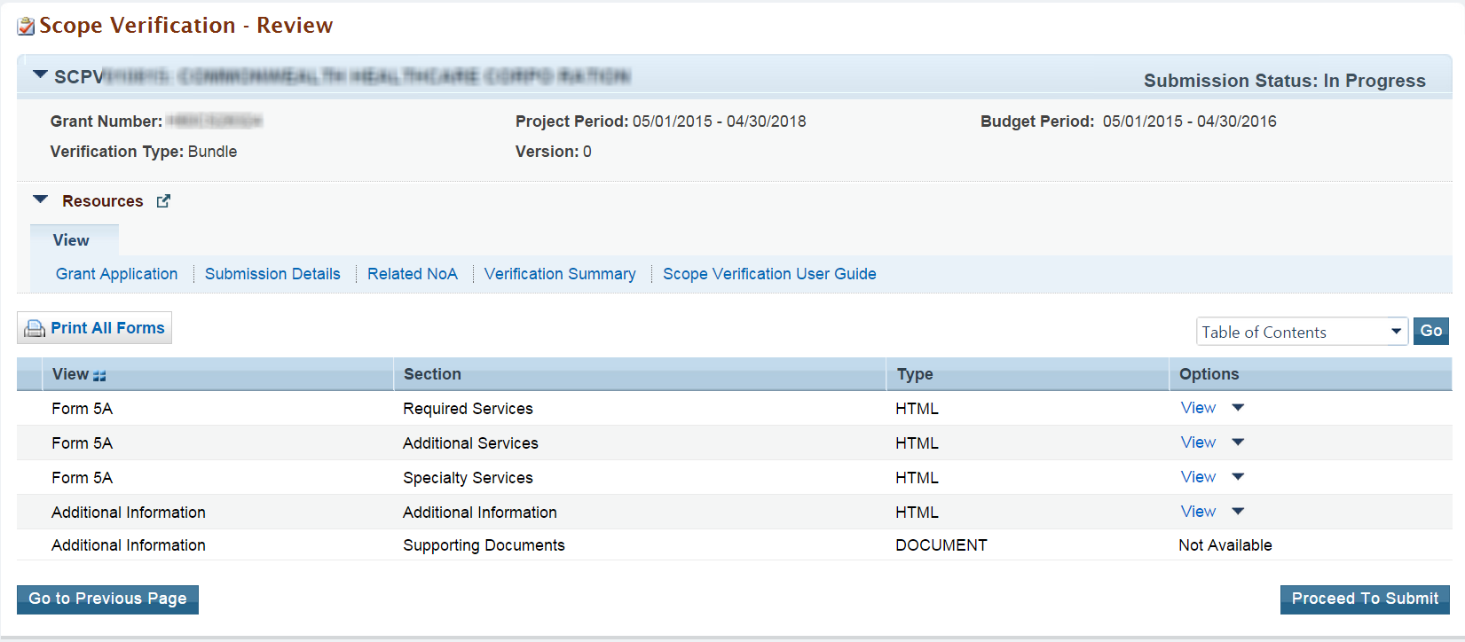
The Submit page (refer to Figure 13), aside from allowing you to submit the submission, provides the status of each section and submission details for each Form 5A section. All sections must be complete in order to submit the Scope Verification. Directly navigate to each of the Form 5A and Additional Information sections by clicking the section’s respective Update link. The Current Submission Details section provides a high-level overview of the submission.
Navigate to the Review page by clicking the Go to Previous Page button. Click the Submit to HRSA button when the Scope Verification is ready for submission. The system will navigate to the Review page with a success message.

Figure 13: Submit Page
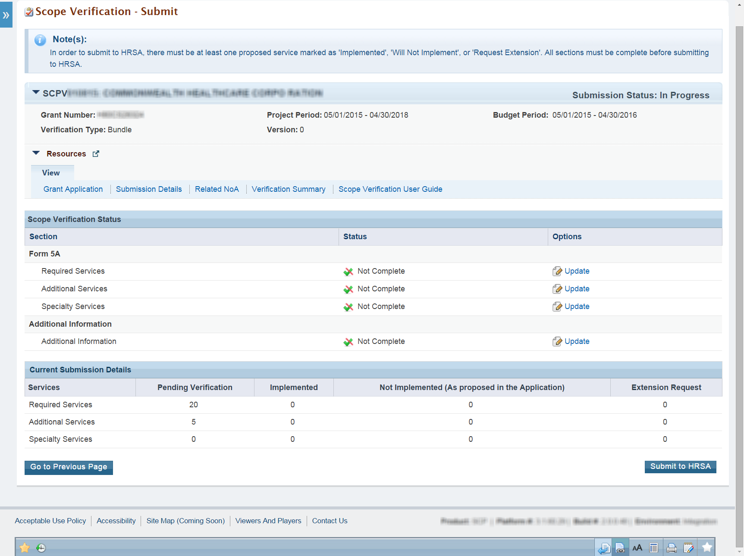

Project Officer Requests Change
HRSA may deem it necessary to return your submission for change request. In this scenario, follow the steps in Section 5 above to navigate to the Submissions – List page, and open your submission as you did initially.
In order to view your project officer’s reasons for requesting a change, access your EHB-registered email account. Open the respective email and read your project officer’s comments.
Note that for Bundled Scope Verifications, you will not be able to edit records that you marked as Implemented or Not Implemented and were approved by BPHC. Services approved by BPHC are indicated by tooltip language respective to each approved service.
A Scope Verification may be returned to you more than once, based on HRSA’s review.

Copying a Change in Scope (CIS) Request
In the case where the Scope Verification expires and is no longer available to work on, you can copy any existing CIS request that you have submitted previously. This will be useful under the following circumstances:
- Proposing multiple changes of the same type (e.g., adding multiple services or sites).
- Making changes to a CIS request after HRSA approves it, but before you verify the proposed change(s), is not allowed, so you will need to withdraw the CIS request and submit a new one.
- Failing to verify an approved request but still needing to make the change, so you will need to submit a new request that is the same as the original one.
Copying a CIS request makes a duplicate of the original including attachments. Data that was entered on the Change Detail page is not copied. Point of contact information that was entered on the Cover Sheet page is not copied.
To copy a CIS request (refer to Figure 14), follow these steps:
- Click the Tasks tab to navigate to the Pending Tasks – List page, listing all the available tasks.
- In the left hand menu, under Grants, click Health Center CIS Requests to navigate to the Change in Scope Request – List page.
- Click the Recently Completed tab to access all the recently completed submission and click the Copy Request button.
Figure 14: Copy Request functionality
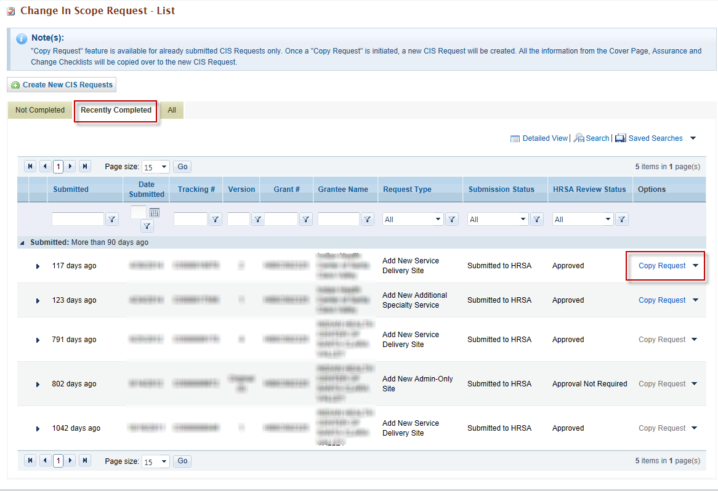

Help and Support
If you have further questions please contact the BPHC Helpline. To receive assistance from the Bureau of Primary Health Care (BPHC) Helpline, please click the following link:
- http://www.hrsa.gov/about/contact/bphc.aspx and submit your inquiry. You may also contact the helpline directly at 1-877-974-BPHC (2742). The BPHC Helpline hours of operation are Monday – Friday 8:30 a.m. – 5:30 p.m. The BPHC Helpline is closed on all Federal holidays. Thank you for contacting us.

