Bureau of Primary Health Care (BPHC)
Bundled Scope Verification:
User Guide for Grantees

Table of Contents
1 Document Purpose 4
2 Process Overview 4
3 Completing the Scope Verification Submission 4
3.1 Accessing the Scope Verification Submission through the Other Submissions Page 5
3.2 Accessing the Scope Verification Submission through the Approved Scope Module 7
3.3 Completing the Scope Verification Submission 10
3.3.1 Form 5A Sections 11
3.3.2 Additional Information 12
3.3.3 A Note on Data Entry 12
3.3.4 Review and Submit 13
4 After You Submit 14
5 Project Officer Requests Change 15
6 Help and Support 15

Table of Figures
Figure 1: Grant Home Page 5
Figure 2: Submissions – Incomplete List 6
Figure 3: Approved Scope in Grants Home Left Menu 7
Figure 4: Self Updates – Services Details 8
Figure 5: Self Updates - Required Service Pending Approved Changes 9
Figure 6: Status Overview Page 10
Figure 7: Sample of a Form 5A Section 11
Figure 8: Additional Information Section 12
Table 1: Section-Level Actions in Scope Verification – Bundled Service Add Submission 13
Figure 9: Review Page 13
Figure 10: Submit Page 14

Document Purpose
The purpose of this document is to provide detailed instructions for completing the process of electronically verifying the addition of required and additional services to your scope of project through the HRSA Electronic Handbooks (EHBs), where these services will be approved in connection with a New Access Point (NAP) or a Service Area Competition (SAC) Type 1 award under the Health Center Cluster grant program.
This user guide is not intended to provide policy guidance. Nor does it replace applicable Policy Information Notices (PINs) or Program Assistance Letters (PALs). These can be reviewed or downloaded at the BPHC website.

Process Overview
Within 120 days of receiving your Notice of Award (NoA), you must verify that the Form 5A services you proposed in your NAP or SAC application are, in fact, “up and running.” You will do this in the HRSA EHBs, by submitting a Bundled Scope Verification Submission. To do this, you must be a registered user, registered with your organization’s Health Center Cluster grant, and you must be either the Project Director (or Financial Reporting Administrator) for the grant or have appropriate permissions from the Project Director (or Financial Reporting Administrator).
You are given 120 calendar days from the date HRSA releases the NoA to implement the changes to your services. Upon the NoA release, a Scope Verification Submission is created in your EHB pending tasks. The proposed changes are reflected in your scope when the NoA is released, but the changes are flagged as “pending verification” and cannot be selected for any purpose (such as another CIS or program specific application) until they are verified or the respective Scope Verification Submission expires.
If you cannot complete the Scope Verification Submission within the 120-day period, you may, through the EHB, request an extension of up to 90 days. Extension requests are subject to review and approval by HRSA. The time HRSA spends reviewing your request will not count against any additional time you may be granted.
If you do not complete the Scope Verification Submission by the deadline date, the Scope Verification Submission expires and no change is made to your scope. If you still want to make the change, a new Change in Scope request needs to be created. If appropriate, you can copy a previously submitted Change in Scope request and submit it with necessary revisions.
Note: The verification clock only ticks while the verification Scope Verification Submission is available for editing in your handbook. If you request an extension, the clock stops while HRSA reviews your request. It starts again when HRSA again makes the Scope Verification Submission available to you. For this reason, it is possible (though not altogether likely) that the Scope Verification process could take longer than the maximum of 210 calendar days to complete.

Completing the Scope Verification Submission
To complete the Scope Verification Submission, login to the HRSA Electronic Handbook and access the Scope Verification Submission.
Note: if you do not have a username, then you must register in EHB. Do not create duplicate accounts. If you experience login issues or forget your password, contact the BPHC Helpline for assistance at http://www.hrsa.gov/about/contact/bphc.aspx or 1-877-974-2742 (Monday – Friday, 8:30 AM - 5:30 PM ET).
There are two methods for accessing the Scope Verification Submission – through the Submissions page, and the Approved Scope page. You may use any of these methods.

Accessing the Scope Verification Submission through the Other Submissions Page
- Navigate to the EHB login and enter your login credentials
- Click the Grants tab to navigate to the My Grant Portfolio – List page.
- Click the Grant Folder link to navigate to the Grant Home page.
- On the Grant Home page, click the Work on Other Submissions link (refer to Figure 1) to navigate to the Submissions page.
Figure 1: Grant Home Page
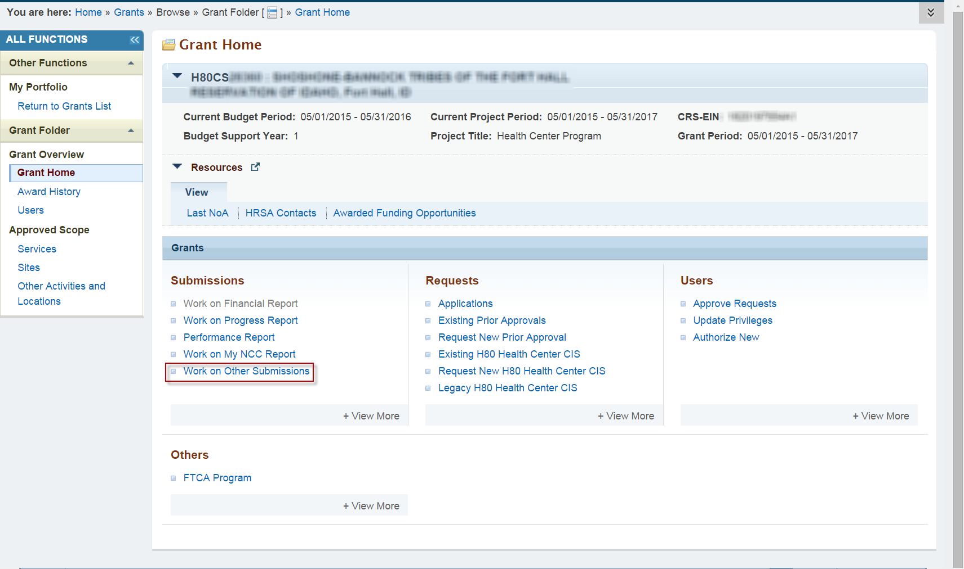
- The Submissions page (refer to Figure 2) lists all of the assigned Scope Verification Submissions, if any. Select the Not Completed tab in order to only see submissions that have not been completed yet.
- Access the search fields by clicking Search. Filter the list page by inputting the Scope Verification tracking number (of a bundled Scope Verification) into the search page field Submission Tracking Number Like. Click Search.
- Click the Start/Edit button of the searched Scope Verification Submission row to access the submission.
Figure 2: Submissions – Incomplete List
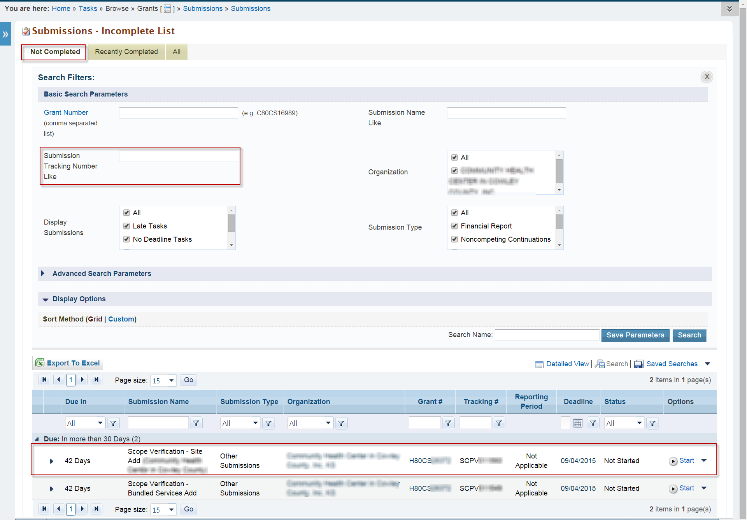
To complete the Scope Verification Submission, proceed to Section 3.3.

Accessing the Scope Verification Submission through the Approved Scope Module
- On the Grants Home page, locate Approved Scope on the left side menu (refer to Figure 3). Under Approved Scope, click Services. This navigates to the Self Updates: Services Details page (refer to Figure 4).
Figure 3: Approved Scope in Grants Home Left Menu
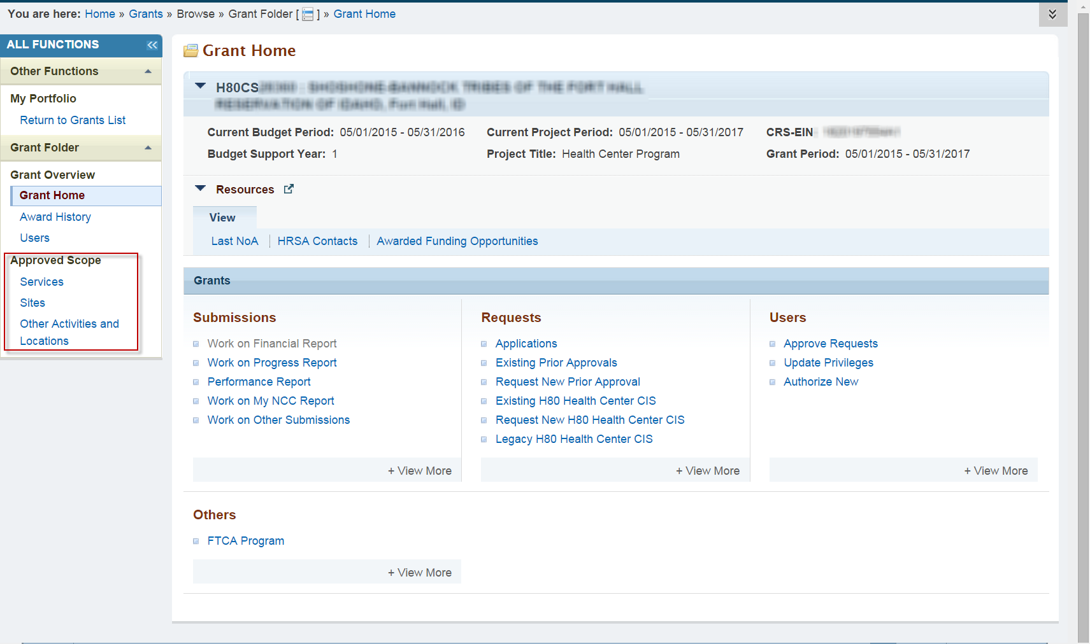
- Click Pending Approved Changes (#) (the (#) indicates the number of services to be verified) under the Required Services column to navigate to the Self Updates: Required Services Pending Approved Changes page (refer to Figure 5). This page lists the services to be verified.
Figure 4: Self Updates – Services Details
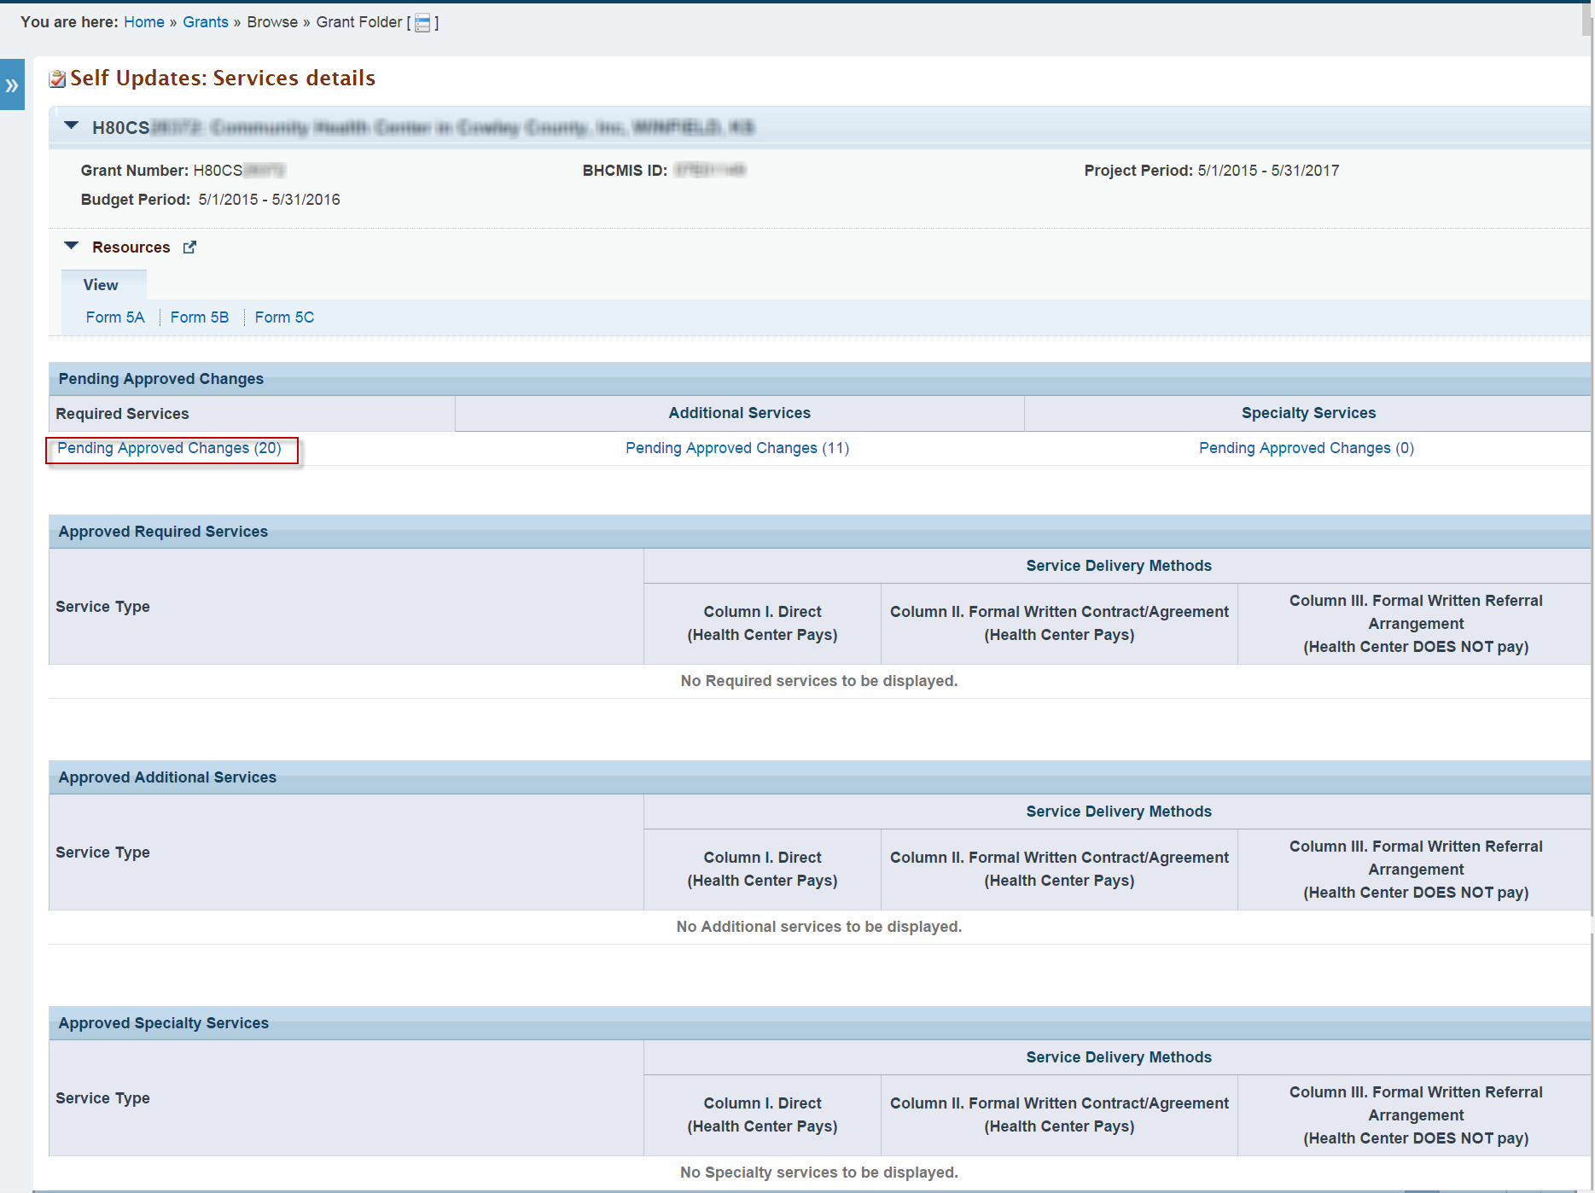

- Click Verify for one of the listed services to open the respective Scope Verification Submission (refer to Figure 5).
Figure 5: Self Updates - Required Service Pending Approved Changes
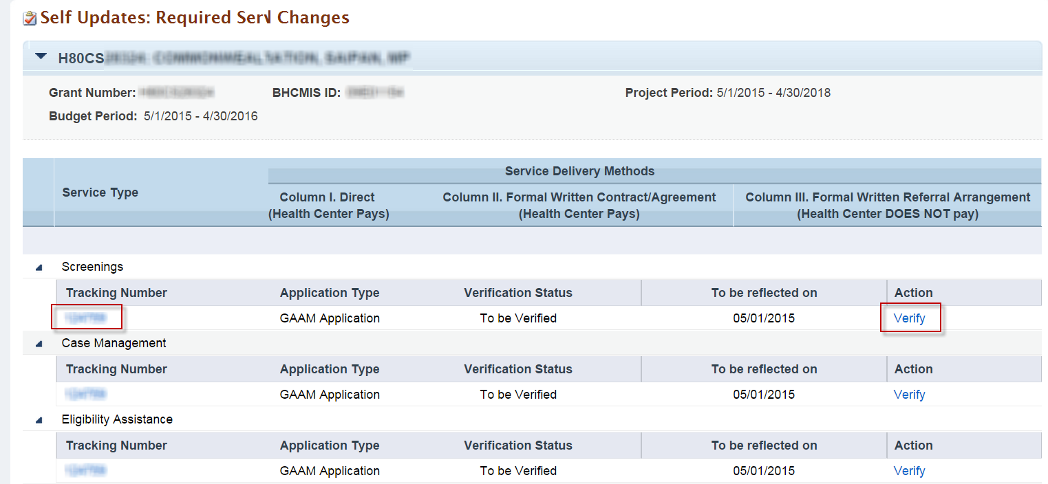
To complete the Scope Verification Submission, proceed to 3.3.

Completing the Scope Verification Submission
Click Start (or Edit) from the Other Submissions, Pending Tasks, or Verify from Approved Scope pages to open the Status Overview page (refer to Figure 6). The left menu provides links that allow you to navigate to any of the pages within the Scope Verification Submission. You can also navigate to any Form 5A section or the Additional Information section by clicking the Update button for each of the sections.
Figure 6: Status Overview Page
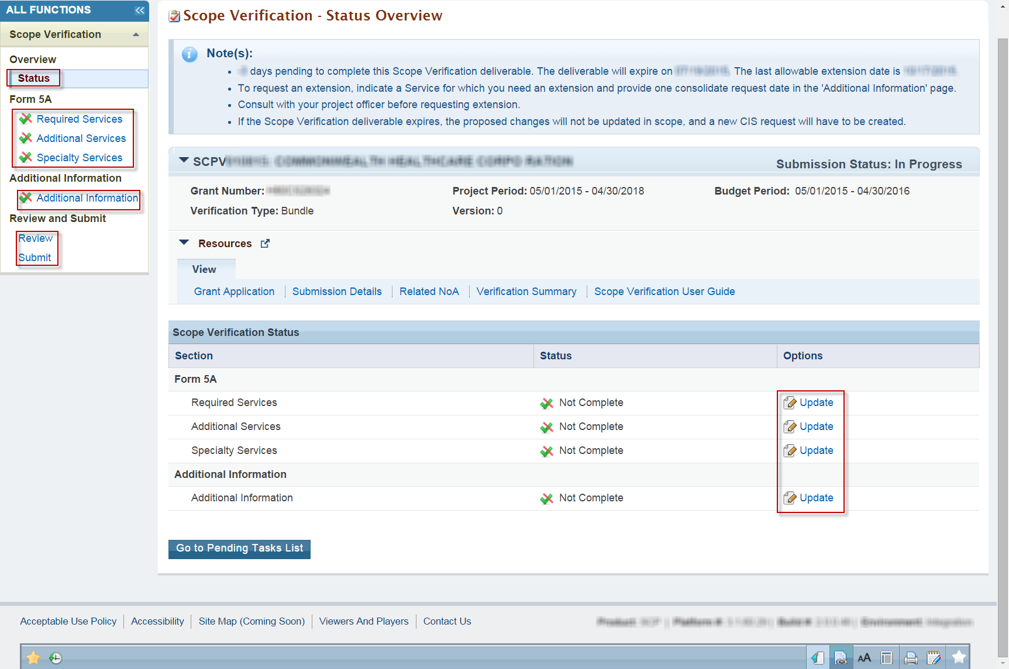

Form 5A Sections
Each of the Form 5A sections (Required Services, Additional Services, Specialty Services) must be completed in order to submit the Scope Verification Submission (refer to Figure 7). Follow the on-screen instructions and tooltip language respective to each decision to complete the Scope Verification Submission. You must select one decision for each service if applicable.
To submit a service as implemented, you must provide an implementation date later than or equal to the NoA Release Date and prior to or equal to the current date.
You can choose to request an extension for each service as necessary. On the Additional Information page (refer to Figure 8), provide only one extension request date for all services you are requesting an extension for.
You cannot submit the Scope Verification Submission with every service marked as Pending Verification.
Navigate to the previous page by clicking the Go to Previous Page button. Click the Save button to save your work on the page. Click the Save and Continue button to save your work on the page and navigate to the next page.
Figure 7: Sample of a Form 5A Section
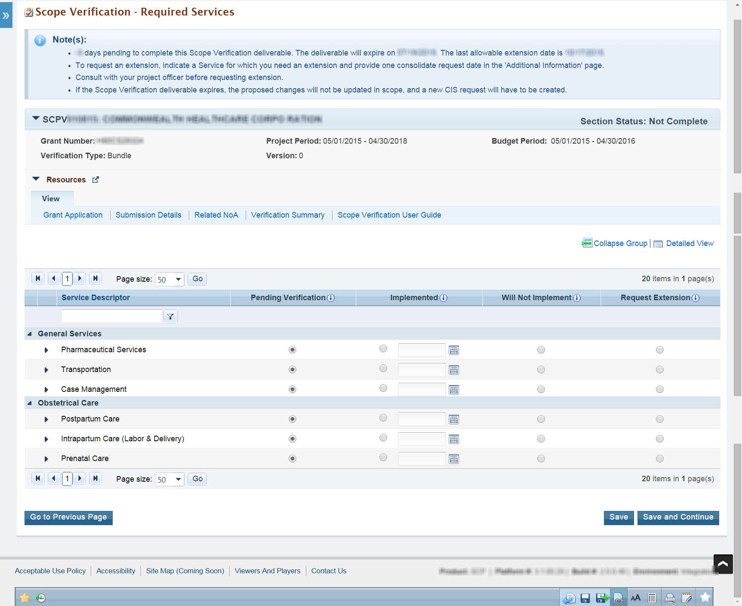

Additional Information
The Additional Information section (refer to Figure 8) is where you can provide the extension request date, comments, and supporting documentation. Supporting documentation is required in order to not implement or request extension for the proposed service(s).
Navigate to the Specialty Services page by clicking the Go to Previous Page button. Click the Save button if you wish to save your work on the page and come back later. Click the Save and Continue button to save your work on the page and navigate to the Review page.
Figure 8: Additional Information Section
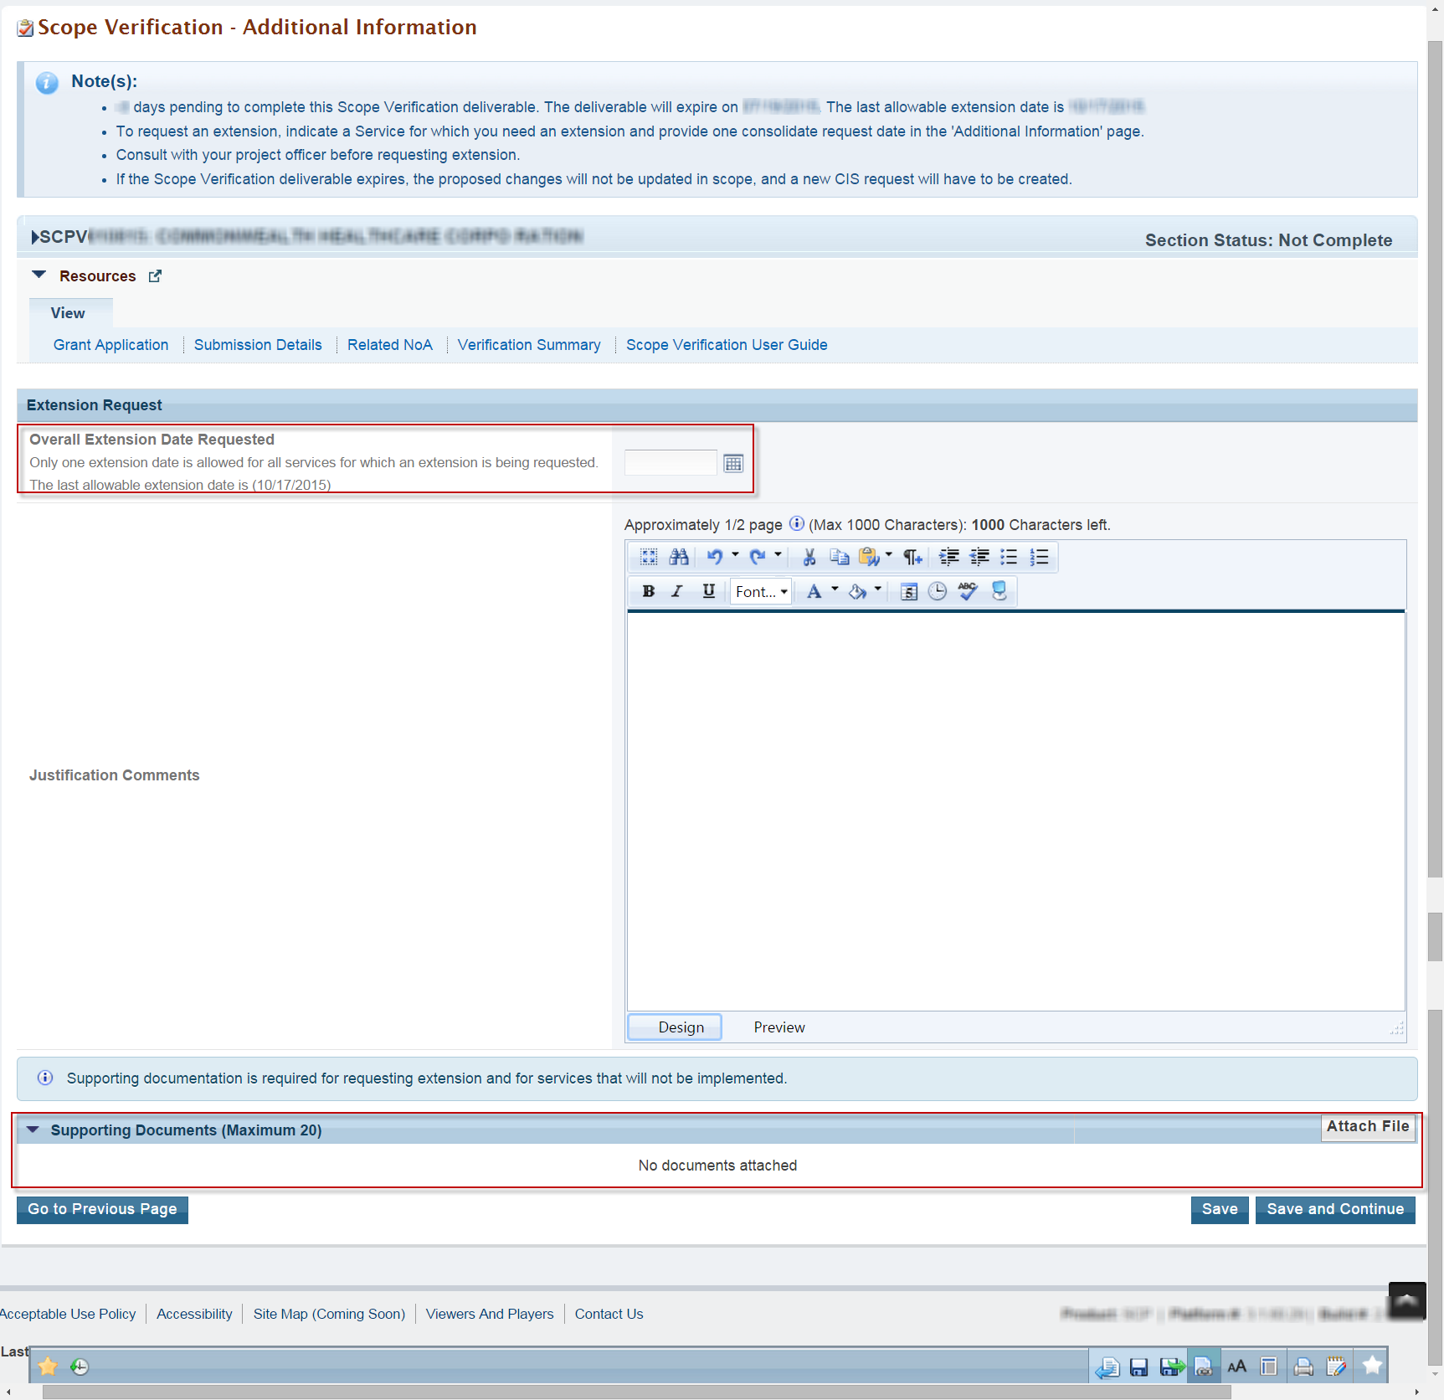

A Note on Data Entry
At the bottom of the page in each Form 5A and Additional Information section, you will find a dropdown list of commands. These commands are described in Table 1.
Table 1: Section-Level Actions in Scope Verification – Bundled Service Add Submission
Action | What It Does
Save | Saves the changes you make in a section and keeps you in that section. Use this to save your work as you go. The system will run validations and display error messages as appropriate when you attempt to save changes. Error messages may prevent your changes from being saved, so do not ignore them.
Save and Continue | Saves the changes you make in a section and takes you to the next section. Use this when you want to save changes to a section and go to the next one. The system will run validations and display error messages as appropriate when you attempt to save changes. Error messages may prevent your changes from being saved, so do not ignore them.

Review and Submit
The Review page (refer to Figure 9) allows access to a read-only view of each of the Form 5A sections, the Additional Information section, and any supporting documentation submitted. Access a read-only view of a section or supporting documentation by clicking the section’s respective View button. Navigate to the Submit page by clicking the Proceed to Submit button.
Figure 9: Review Page
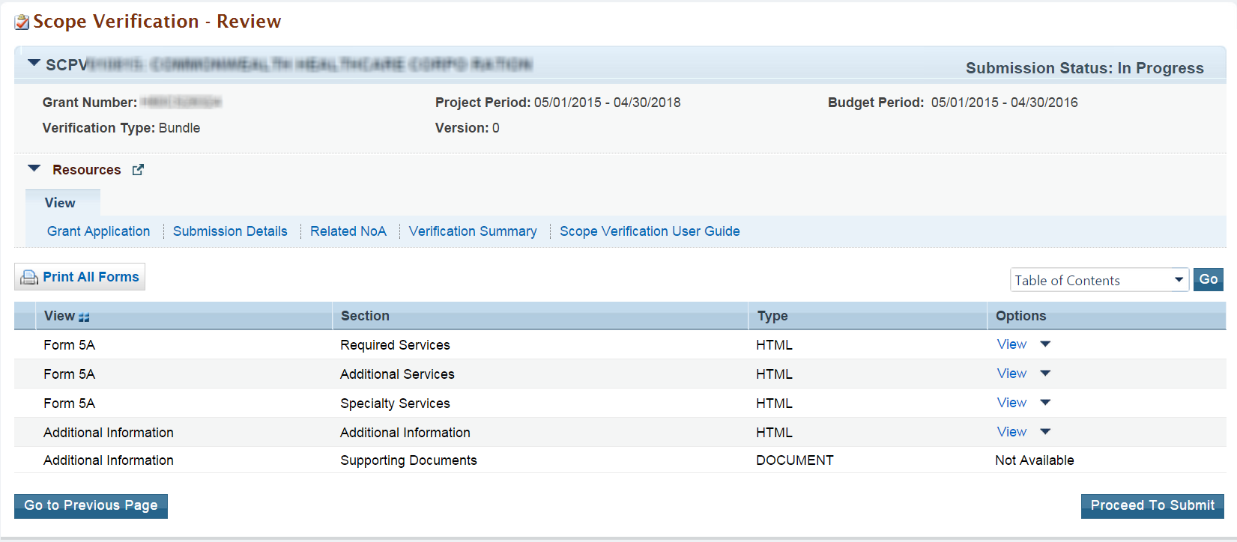

The Submit page (refer to Figure 10) provides the status of each section and submission details for each Form 5A section. All sections must be complete in order to submit the Scope Verification. Directly navigate to each of the Form 5A and Additional Information sections by clicking the section’s respective Update link. The Current Submission Details section provides a high-level overview of the submission.
Navigate to the Review page by clicking the Go to Previous Page button. Click the Submit to HRSA button when the Scope Verification is ready for submission. The system will navigate to the Review page with a success message.
Figure 10: Submit Page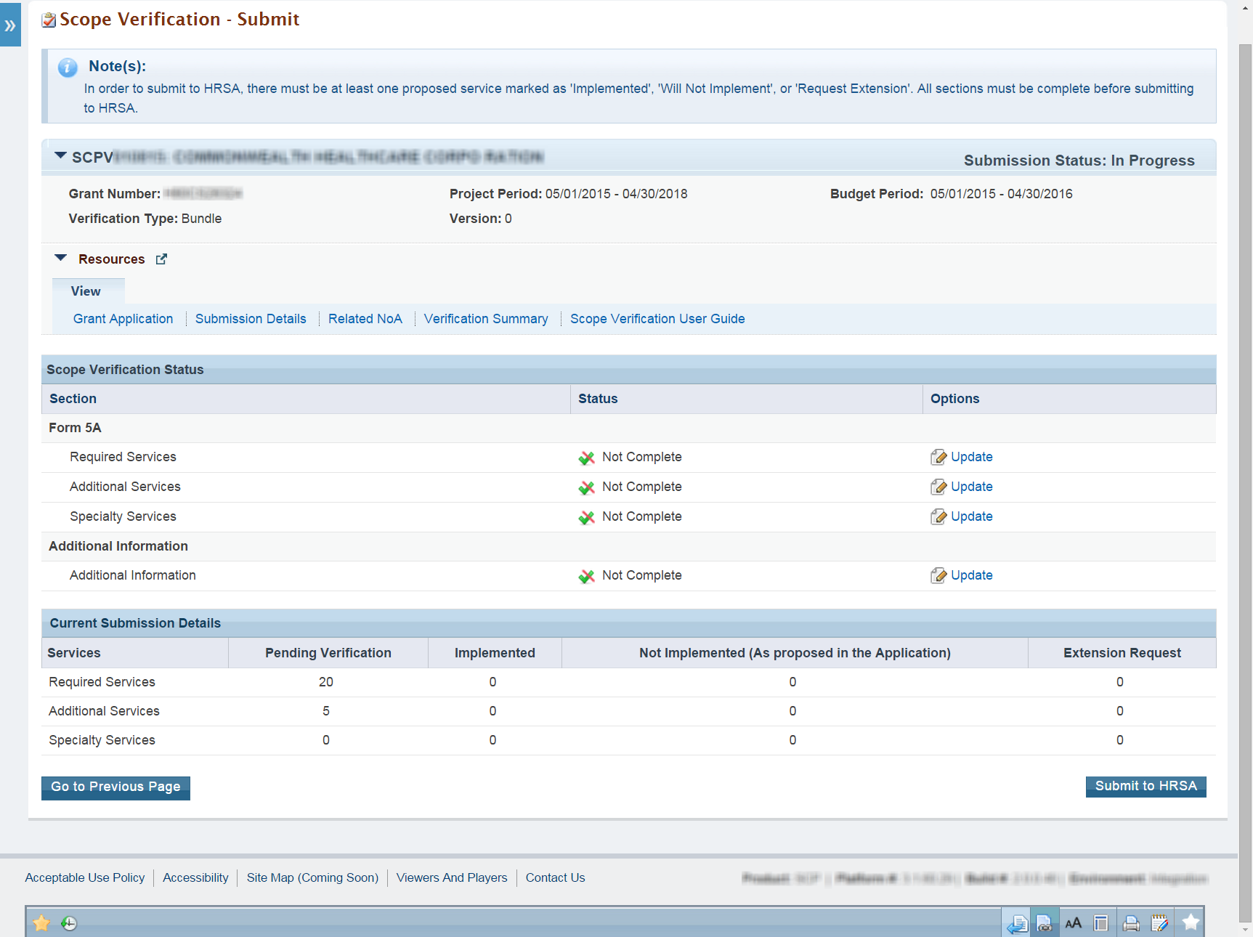

After You Submit
When you submit your Scope Verification – Bundled Service Add submission, the submission status will move to “Submitted” and the submission will be removed from the Other Submissions list page. You will still be able to view your submission.
To view your submission, take the following steps:
- Follow the steps in Section 3.2 above to navigate to the Submissions page.
- On the Submissions page, click the Search button. The system displays the Search page. On the Search page, set search parameters to find submissions matching the Scope Verification Tracking Number and that are submitted. Click the Search button.
- Submissions matching your search parameters are displayed.
- Click View Submission to open a read-only copy of the submission.

Project Officer Requests Change
HRSA may deem it necessary to return your submission for change request. In this scenario, follow the steps in Section 3 above to navigate to the Submissions – List page, and open your submission as you did initially.
In order to view your project officer’s reasons for requesting a change, access your EHB-registered email account. Open the relevant email and read your project officer’s comments.
Services that were marked as Implemented or Not Implemented and approved by BPHC are not editable. Services approved by BPHC are indicated by tooltip language respective to each approved service.
On the Form 5A sections, services marked for change request are indicated by the column Is Change Requested by PO? This column will only be displayed if the submission has been sent back to you for change request.
A Scope Verification Submission may be returned to you more than once, based on HRSA’s review.

Help and Support
If you have further questions please contact the BPHC Helpline. To receive assistance from the Bureau of Primary Health Care (BPHC) Helpline, please click the following link:
- http://www.hrsa.gov/about/contact/bphc.aspx and submit your inquiry. You may also contact the Helpline directly at 1-877-974-BPHC (2742). The BPHC Helpline hours of operation are Monday – Friday 8:30 a.m. – 5:30 p.m. The BPHC Helpline is closed on all Federal holidays. Thank you for contacting us.

